Day 3 Lab Manual

UNIVARIATE ANALYSIS IN R - MEASURES OF CENTRAL TENDENCY

NAME: U.Mohan Srinivas

REGNO:192110320

I. ARITHMETIC MEAN

a) Write suitable R code to compute the average of the following values.

12,7,3,4.2,18,2,54,-21,8,-5

b) Compute the mean after applying the trim option and removing 3 values from each

end.

c) Compute the mean of the following vector .

(12,7,3,4.2,18,2,54,-21,8,-5,NA)

#If there are missing values, then the mean function returns NA.

# Find mean dropping NA values.

#To drop the missing values from the calculation use na.rm = TRUE

SOURCE CODE:

a)

values <- c(12, 7, 3, 4.2, 18, 2, 54, -21, 8, -5)

print(mean_value)

OUTPUT:

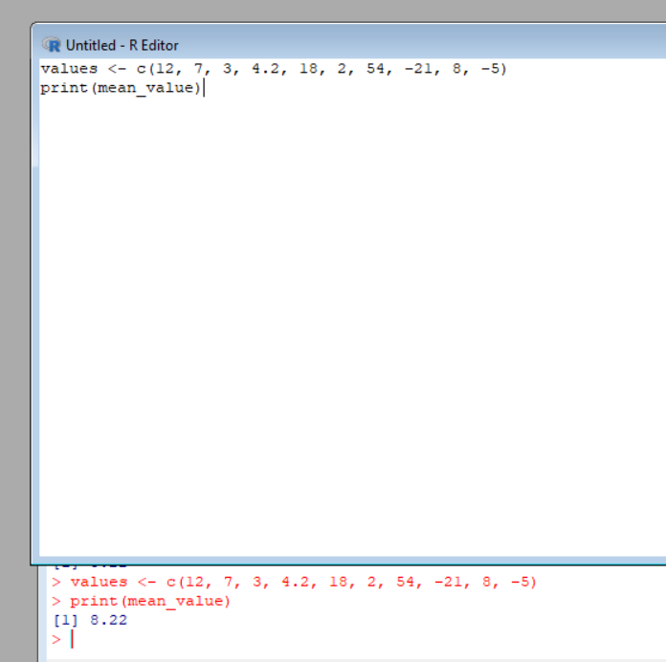

b)

SOURCE CODE:

values <- c(12, 7, 3, 4.2, 18, 2, 54, -21, 8, -5)

trimmed_mean <- mean(values, trim = 3/length(values))

print(trimmed_mean)

OUTPUT:

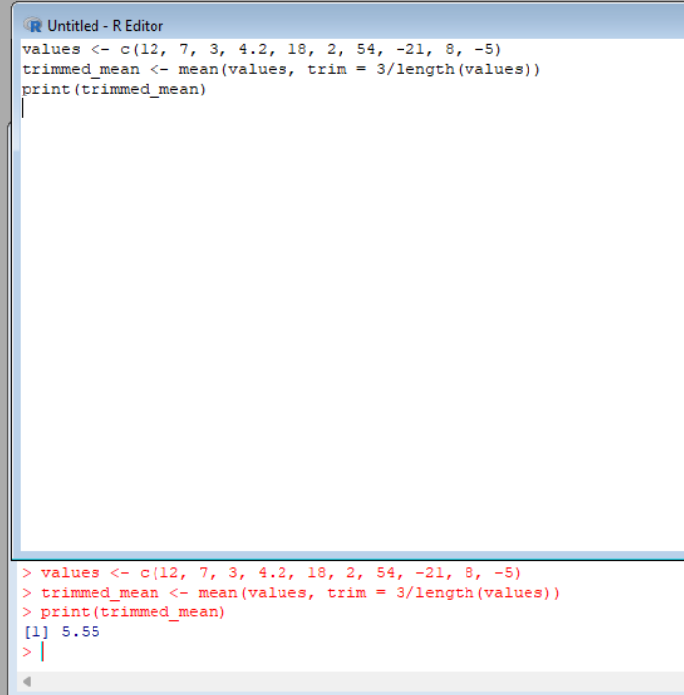

c)

SOURCE CODE: values <- c(12, 7, 3, 4.2, 18, 2, 54, -21, 8, -5, NA)

mean_value <- mean(values, na.rm = TRUE)

print(mean_value)

OUTPUT:

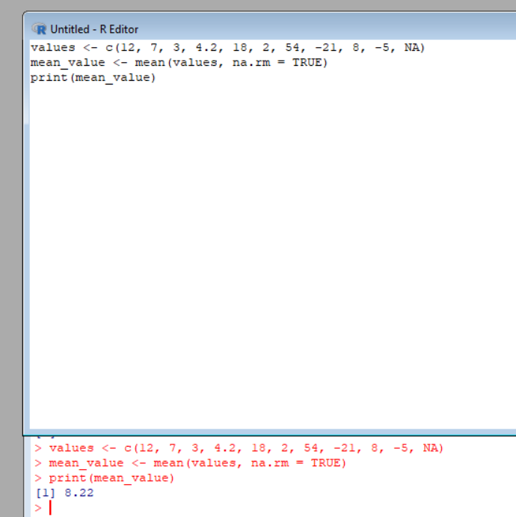

II.MEDIAN

Write suitable R code to compute the median of the following values.

12,7,3,4.2,18,2,54,-21,8,-5

SOURCE CODE:

values <- c(12, 7, 3, 4.2, 18, 2, 54, -21, 8, -5)

print(median_value)

OUTPUT:

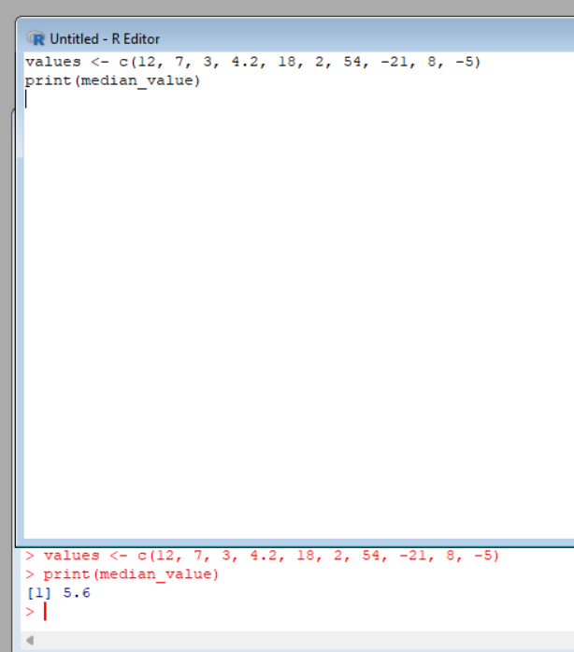

III. MODE

Calculate the mode for the following numeric as well as character data set in R.

(2,1,2,3,1,2,3,4,1,5,5,3,2,3) , (&quot;o&quot;,&quot;it&quot;,&quot;the&quot;,&quot;it&quot;,&quot;it&quot;)

SOURCE CODE:

-> For the numeric data set (2,1,2,3,1,2,3,4,1,5,5,3,2,3)

data_numeric <- c(2, 1, 2, 3, 1, 2, 3, 4, 1, 5, 5, 3, 2, 3)

mode_numeric <- as.numeric(names(table(data_numeric)[table(data_numeric) == max(table(data_numeric))]))

mode_numeric

-> For the character data set ("o","it","the","it","it"):

data_character <- c("o", "it", "the", "it", "it")

mode_character <- names(table(data_character)[table(data_character) == max(table(data_character))])

mode_character

OUTPUT:

